**Countries which Indian Citizen Can Travel Without Visa**

Visa

It is however important to note that there is usually a time limit to how long you can stay in each country which varies significantly. Also, depending on the purpose of travel and how long you intend to stay, you could be eligible to apply for visa or an extension if you were issued one on arrival as the case may be.

Before you travel consult embassy  or consulate of the country you are planning to travel to at a time very close to when you intend to travel to confirm that there has not been any recent changes that may affect your travel.

♦ **Hong Kong-**Visa not required valid till 14 days

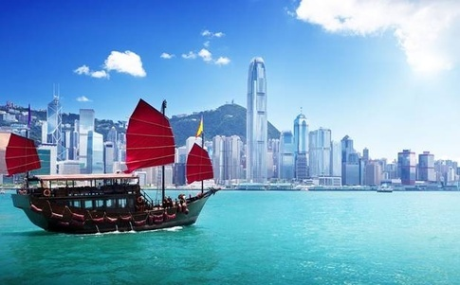

**♦ Cape Verde-***Visa on arrival*

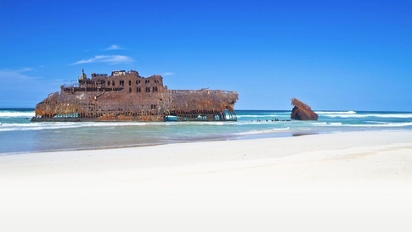

**♦ Comoros Islands–**Visa on arrival

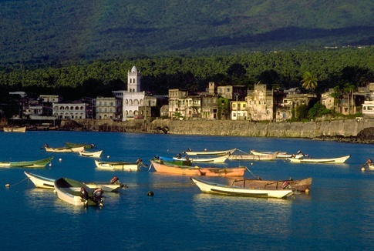

**♦ Djibouti-**Visa on arrival

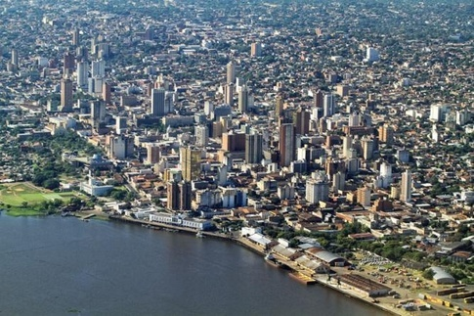

♦[**Ethiopia**](http://www.solorider.in/Athirapallyroad,athirappilly,dam,enfield,Goa,kanyakumari,kerala,madhurai,OOTY,pambanbridge,Peringalkuthudam,RamanathaswamyTempletower,Rameswaram,RE,ride,ridermania,ridermania2014,ridingsolo,Royalenfield,solorider,solotrip,southindia,tamilnadu,TBTS,tbts350,thiruvalluvarstatue,thunderbird,vagator/ethiopia/)– Visa on arrival



♦ **Madagascar** -Visa on arrival  valid till 30 days

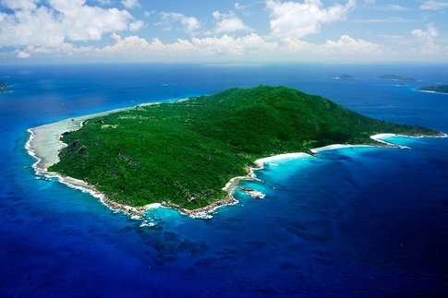

♦ **Maldives**– Visa on arrival  valid till 30 days



♦ **Saint Lucia**– Visa on arrival  valid till 6 weeks

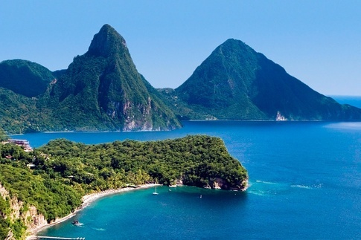

♦ [**Samoa**](http://www.solorider.in/Athirapallyroad,athirappilly,dam,enfield,Goa,kanyakumari,kerala,madhurai,OOTY,pambanbridge,Peringalkuthudam,RamanathaswamyTempletower,Rameswaram,RE,ride,ridermania,ridermania2014,ridingsolo,Royalenfield,solorider,solotrip,southindia,tamilnadu,TBTS,tbts350,thiruvalluvarstatue,thunderbird,vagator/samoa/)–  Entry Permit for a max. stay of 60 days on arrival.



♦ **Jordan**– Visa on arrival valid till  2 weeks, must hold US$ 1000



♦ **Kenya**–   Visa on arrival valid till 3 months



♦ **Indonesia**– Visa on arrival  valid till 30 days

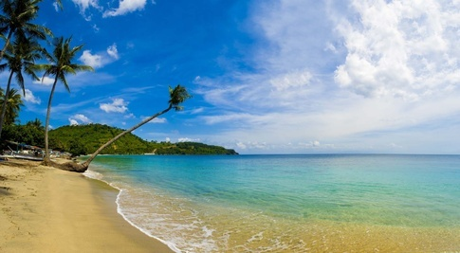

♦ **Laos**– Visa on arrival  valid till 30 days

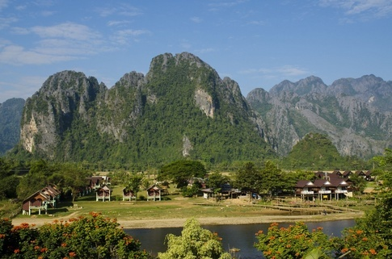

♦ **Seychelles** – Visa on arrival  valid till  1 month

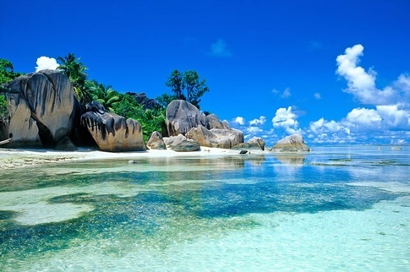

♦ **Palau-**Visa on arrival  valid till 30 days

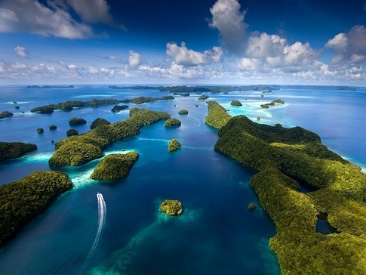

♦ **Dominica-**Visa not required

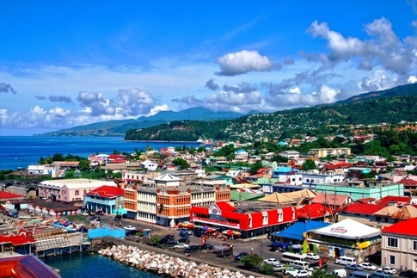

**♦ Ecuador–**Visa not required

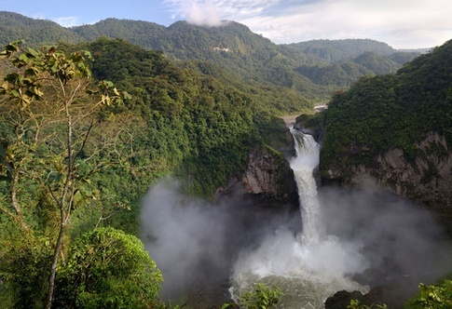

♦ **El Salvador-**Visa not required

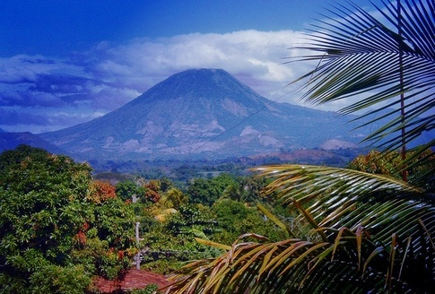

♦ **Fiji**–  Visa not required

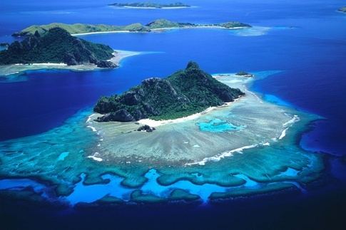

**♦ Haiti –**Visa not required

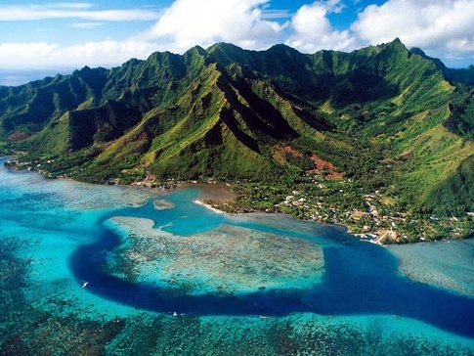

**♦Micronesia-**Visa not required

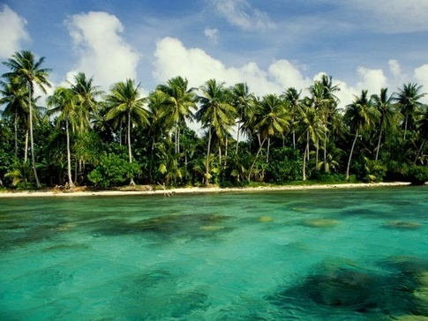

**♦ Nepal**– Indian citizens may live and work freely in Nepal under the terms of the [1950 Indo-Nepal Treaty of Peace and Friendship](https://www.wikiwand.com/en/1950_Indo-Nepal_Treaty_of_Peace_and_Friendship).

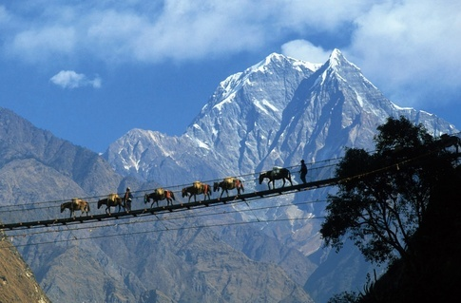

♦ **Bhutan** – Visa not required



♦ **Grenada**–  Visa not required

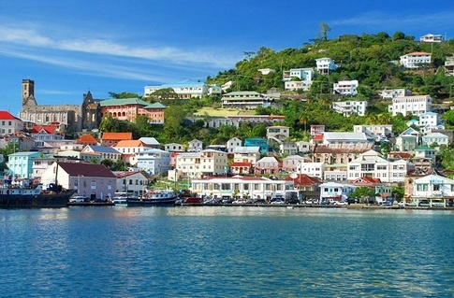

♦ **Mauritius-**Visa not required

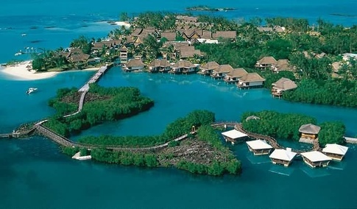

♦ **[Réunion](http://www.solorider.in/Athirapallyroad,athirappilly,dam,enfield,Goa,kanyakumari,kerala,madhurai,OOTY,pambanbridge,Peringalkuthudam,RamanathaswamyTempletower,Rameswaram,RE,ride,ridermania,ridermania2014,ridingsolo,Royalenfield,solorider,solotrip,southindia,tamilnadu,TBTS,tbts350,thiruvalluvarstatue,thunderbird,vagator/reunion/" \o "See the tag: reunion (1 post))** –  Visa not required valid till 15  days



**♦ Saint Vincent and the Grenadines –**Visa not required

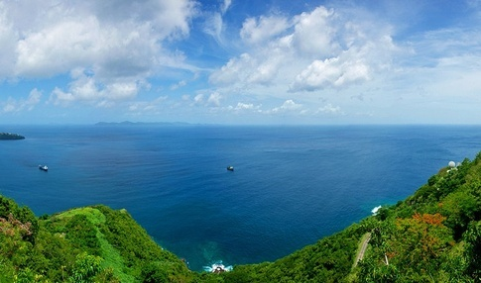

♦ **British Virgin Islands-**Visa not required valid till 30 days

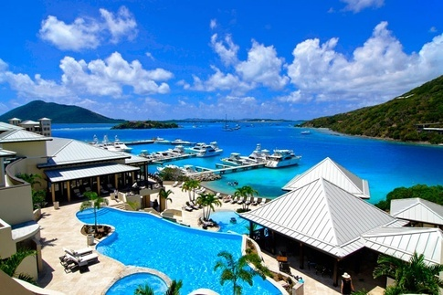

♦ **Montserrat-**Visa not required

